Table of Contents

Learning Journey Assistant — CLI Pipeline
Version | 2.0, 3 October 2026. Supersedes the 12 August 2026 page.
Describes | main at b4ccebd (3 Oct 2026)
Source | docs/design/cli-pipeline.md; diagram from docs/handover/diagrams/04-seq-pipeline.mmd. Rebuild with docs/design/build.sh

What python -m lja.cli does
One command turns a workbook, or a Moodle database, into competency clusters and a per-student gap report. It has exactly one step that touches a model, and that step is cached so a normal re-run never re-spends the call.
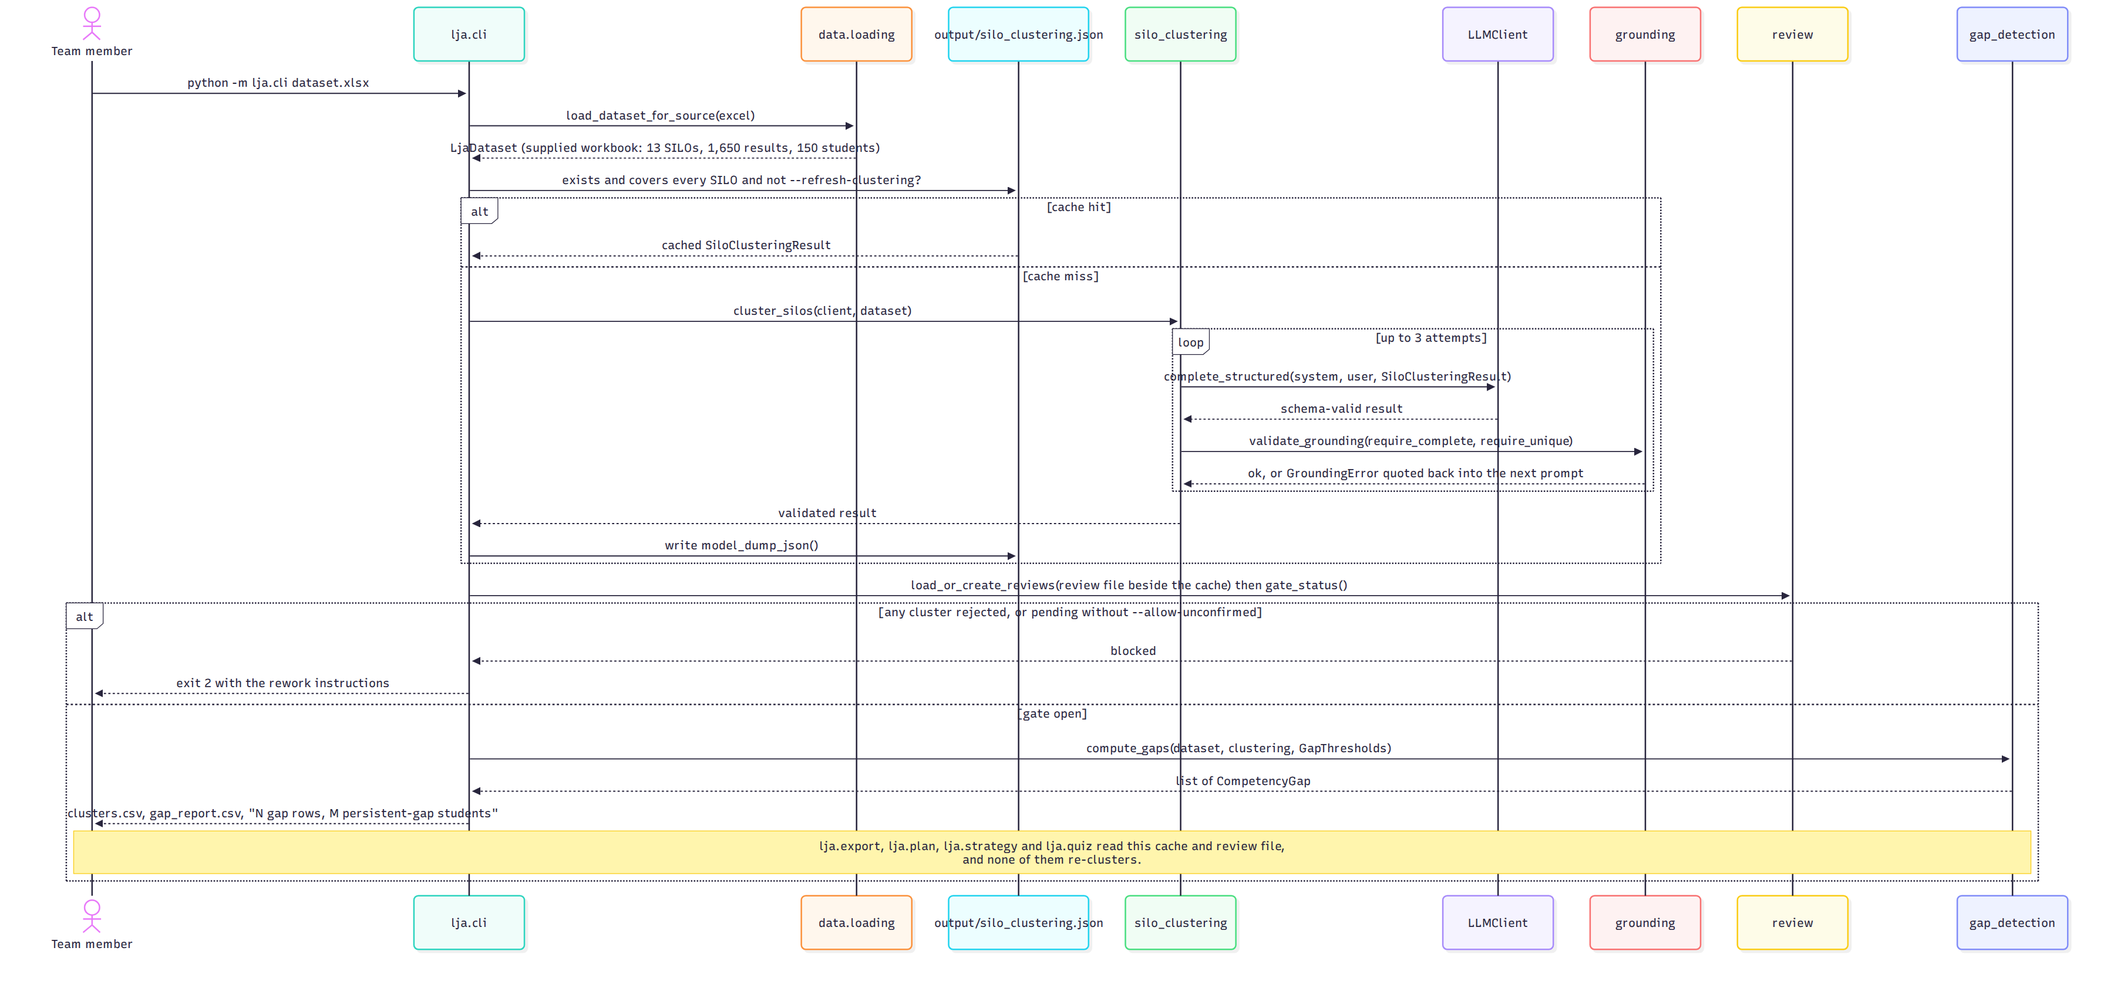
Running the pipeline
Figure 1: Load, cluster (cached), gate, classify. Source: docs/handover/diagrams/04-seq-pipeline.mmd.
Step | Where | What happens | Exit
Load | lja.data.loading | --source excel reads the three workbook sheets; --source moodle runs SQL Query 2 as lja_reader and joins the criterion-to-SILO CSV. Both return one LjaDataset. | 2 on a malformed workbook or an unmapped criterion
Cluster, or read the cache | lja.model.silo_clustering | If output/silo_clustering.json (or --clustering-cache) exists and covers every SILO, no model call. Otherwise one structured call; the result must place every SILO in exactly one cluster, and a miss is quoted back into a retry, up to three attempts. | 1 if no attempt passes coverage
Gate | lja.review | The review file beside the cache holds pending / confirmed / rejected per cluster. Any rejected cluster stops the run and prints the reviewer’s note as rework instructions. Pending clusters stop it too unless --allow-unconfirmed. | 2 when blocked
Classify | lja.model.gap_detection | For every student and competency: weighted attainment, then floor, ceiling, flat-profile fallback, relative position against the student’s own median and MAD. Persistent when two or more subjects evidence the gap.
Write |  | output/clusters.csv (one row per SILO, then the SILO definitions) and output/gap_report.csv (student, competency, attainment, subjects evidencing, observations, classification, basis, relative position). | 0
Every threshold is an environment variable with a CLI flag (--absolute-floor, --relative-gap-cutoff, --min-spread, …) so a sensitivity sweep is a loop in a shell, not a code change. The values are proposals, not ratified (action A-01); the dashboard’s Provenance page shows the ones in force.

The commands that read what it wrote
None of these re-clusters. Each reads the cache and the review file the pipeline left, and each is run deliberately, because the generating ones cost model calls.
Command | Produces | Model calls
python -m lja.review | Confirm or reject clusters; a rejection needs a note | none
python -m lja.plan <xlsx> STUxxxx | A learning plan: what to work on, with evidence and actions, grounded name by name | 1 per attempt, up to 3
python -m lja.strategy <xlsx> STUxxxx | A study strategy: how to study each gap, techniques from a closed evidence-based list, grounded per competency | 1 per attempt
python -m lja.quiz <xlsx> STUxxxx | A practice quiz per gap, multiple choice or written task, plus a blind educator review; the answer key is unverifiable and the page says so | 1 per attempt + 1 review
python -m lja.export <xlsx> --out DIR | students.csv, competencies.csv, cohort.csv, manifest.json; --anonymise pseudonymises ids with a keyed HMAC | none
python -m lja.dashboard | Serves the run; classifies at start-up from the workbook and cache | none on a page load; the opt-in Generate button runs lja.plan / lja.quiz as a subprocess

Reading the diagram
Cache hit or miss. Checked before anything else runs. If the cache exists, covers every SILO in the dataset and --refresh-clustering was not passed, the model branch is skipped and the run is free. Adding a subject with new SILOs makes the cache stale and triggers a re-cluster; existing review decisions survive for any cluster whose membership is unchanged, because a cluster’s id is a hash of its members.
The retry loop. The grounding validator checks the response against the input, not just its shape. A live run in August produced schema-valid JSON that silently dropped three of thirteen SILOs; Pydantic cannot see a completeness problem, only a comparison with the dataset can. The same validator, with different reference lists, is what every generated artefact passes through.
Scale. The single call holds for the three-subject workbook (13 SILOs) and fails on a 52-SILO catalogue on the 30B local model. The handbook tagger (lja.data.competency_tagger, embeddings plus k-means with the model labelling clusters in batches) grouped 1,436 real SILOs in 64 seconds and is the staged answer; wiring it into cluster_silos() is the next clustering work package.

Timings on the supplied workbook
Load, classify, write (cache hit) | under 2 s
First clustering call, qwen3-vl:30b via Ollama | minutes; run-to-run variance is why the cache and the review file exist
One learning plan, qwen/qwen3-vl-30b via LM Studio | 17 to 35 s
Test suite, offline | 365 tests, about 3.5 s

